# 3200105872 庄毅非

# Chapter 6

1．The maximum payload of a TCP segment is 65495 bytes. Why was such a strange number chosen?

答：

因为ip数据帧最大是65535B，对于一个tcp报文段，去掉20B的IP Header和20B的Tcp Header之后，能够承载的tcp数据段就是65535 - 20 - 20 = 65495B

2．If the TCP round-trip time RTT is currently 30 msec and the following acknowledgements come in after 26, 32 and 24 msec, respectively, what is the new RTT estimate using the Jacobson algorithm? Use a = 0.9.

答：

RTT1 = 30 * 0.9 + 26 * 0.1 = 29.6  
 RTT2 = 29.6 * 0.9 + 32 * 0.1 = 29.84

RTT3 = 29.84 * 0.9 + 24 * 0.1 = 29.256

3．In a network that has a maximum TPDU size of 128 bytes, a maximum TPDU lifetime of 30 sec, and an 8-bit sequence number, what is the maximum data rate per connection?

答：

网络在30秒的时间内，最多发送256 / 128 = 2个数据包，那么速率= 2 * 128 / 30 * 8 b/s= 68.3 b/s

4．To get around the problem of sequence number wrapping around while old packets still exist, one could use 64-bit sequence number. However, theoretically, an optical fiber can run at 75 Tbps. What maximum packet lifetime is required to make sure that future 75 Tbps networks do not have wraparound problems even with 64-bit sequence numbers? Assume that each byte has its own sequence number, as TCP does.

答：  
 word不好加上公式，下面是用markdwon写的解答过程，答案是近似497.1小时。

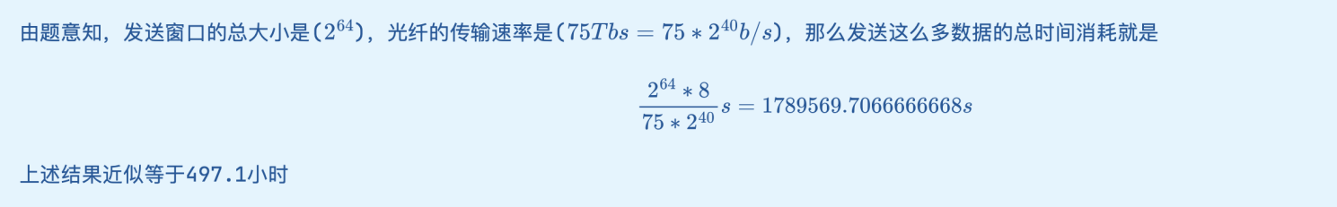

# Chapter 7

1. Can a machine with a single DNS name have multiple IP addresses? How could this occur?

答：

一个域名可以对应多个ip地址，比如一个设备插上了多个网卡，它就有可能拥有多个ip，这在服务器负载均衡中比较常用。

1. A binary file is 3072 bytes long. How long will it be if encoded using base64 encoding, with a CR+LF pair inserted after every 80 bytes sent and at the end?

答：

首先，根据base64编码算法，3072字节的原字符串被转化为3072 * 4 / 3 = 4096字节的字符串，由于一个行有80字节，那么一共有4096 / 80 = 52行，所以最后发送的总字节数 = 4096 + 52 * 2 = 4200字节

1. From an ISP's point of view, POP3 and IMAP differ in an important way. POP3 users generally empty their mailboxes every day. IMAP users keep their mail on the server indefinitely. Imagine that you were called in to advise an ISP on which protocol it should support. What considerations would you bring up?

答：  
 我们可以提的建议包括以下几点。

1. isp提供的服务器面向的用户群体如何，如果用户需求仅仅是简单的在本地将服务器上的邮件下载下来阅读，那么使用pop3就可以；如果用户要求有一定的交互性，在本地可以管理服务器上的邮件，并且按需进行下载，那么可以选择使用imap。
2. isp提供的服务器是否支持用户从多个客户端进行登录，如果需要的话，应该使用imap协议。
3. The standard http URL assumes that the Web server is listening on port 80. However, it is possible for a Web server to listen to some other port. Devise a reasonable syntax for a URL accessing a file on a nonstandard port

答：格式应该是http://xx.xx.xx.xx:yyyy/filepath/filename。比如服务器ip地址是211.11.11.11，http服务端口设置为4000，文件路径为/public/static/mac.c，那么最终url可以是http://211.11.11.11:4000/public/static/main.c。

1. Imagine that someone in the CS Department at Stanford has just written a new program that he wants to distribute by FTP. He puts the program in the FTP directory ftp/pub/freebies/newprog.c. What is the URL for this program likely to be?

答：

ftp://www.cs.stanford.edu/ftp/pub/freebies/newprog.c